

TECH HUB

TECH TIPS AND TUTORIALS

233017_Muhammad FAhad shabbir & 231648_muhammad ahmad

**INSTRUCTOR: MS. ROMANA Maroof**

A Project Report for End Semester Project

**WEBSITE ON TECH TIPS AND TUTORIALS**

* **NAME OF WEBSITE: TECHHUB**

**INTRODUCTION**

In this technology-driven world, it is important to stay up-to-date and aware of innovations. Whether you're a tech enthusiast, a developer, or someone looking to explore the digital world, TechHub is your go-to for tech tips, tutorials, and insight.   
As TechHub, we believe that technology should be accessible to everyone. Our goal is to take the complexity out of the digital environment and provide you with the information you need to make the most of new hardware, software and innovations. We cover a wide range of tech topics, news, inventions and much more.

## ***P*HASE *- I* (*Planning Phase)***

~**Purpose**~

The purpose of our website is to provide the world with a professional Tech website which serves as a sophisticated purpose, serving as active hub for information. They keep users abreast of the ever-evolving tech landscape through timely news updates, insightful analyses, and in-depth reviews of the latest gadgets and software.

~**Audience**~

The target audience for Tech websites can vary based on the website’s specific focus, content, and goals. However, target audiences for tech websites include.

Tech Enthusiast, Professionals in tech industry, Consumers, Learners, Gamers, Startups, and entrepreneurs, Digital marketers, and General audience.

~**Layout on Figma**~

The color scheme of the website is Orange, Black and white.

It consists of Home, Feature, News and Contact details in header.

We have given social links in footer with our logo and other user helping details.

Templates and the data which we used was like what we saw on the links below: -

<https://www.newscientist.com/subject/technology/>

<https://www.google.com/url?sa=i&url=https%3A%2F%2Fwww.lux.camera%2Fiphone-15-pro-max-review%2F&psig=AOvVaw3QoT_0VYf9UAXD62rtOKhf&ust=1702145776826000&source=images&cd=vfe&opi=89978449&ved=2ahUKEwjMsKukuYCDAxUvUKQEHZ1zBcIQr4kDegUIARCgAQ>

<https://venturebeat.com/>

~**Wireframes and Prototypes**~

=>Wireframes are simplified sketches that outline the structure and layout of a webpage. Following are the wireframes of our website:

1. Home page

* Three Pages with interactive feed and pictures representing our products.

1. Features

* An Informative page with separate compartments for each device’s new features and information such as date of release etc.

1. News

* The Page appears like a newspaper having information text boxes updated frequently on daily basis, providing a clean shape of proper news page.

1. Contact

* Well defined logos of each such as socials (Instagram, Facebook, etc.) and mails such as Gmail.

1. Login/Signup

* The proper interactive form for user to provide with inputs or another directed page for non-members to input data into a form and become a member to our club.

=>prototype is a more interactive representation of the website's functionality.

1. Home page

* Consisting of all the content related to technology and new launching products being displayed.

1. Features

* All the new features in our products that will be provided to the user.

1. News

* The latest news about tech reforms or newly launched products and reviews of those devices or products by the end users.

1. Contact

* Contact information or the easiest way to approach us through socials or emails.

1. Login/Signup

* Be a member if you aren’t already. Stay updated and tuned. Connected to the latest technology of the world.

~**Design And color Scheme**~

The color of the website is very minimalistic and bright giving a proper sense of a Tech website. The design is modern as compared to other types of websites and attracting user towards its famous products and technology from around the world. Use of new tutorials and pictures of products has made the website like more elegant.

## ***P*HASE *- II* (*Software Engineering Basics)***

~**Project Requirement**~

We are going to focus on describing the website in terms of product perspective, product features, product information and characteristics, assumptions, and dependencies on the following section of this document. Next, we will address specific information regarding the new tech products on the website, which will enclose data of products, release date of the products, performance of the products. The website consists of 3 introductory front landing pages with separate page for each genre.

The following are the main features that are included in this website:

● **User account:** The webpage allows the user to create their accounts in

the database and provide features of updating and viewing profiles with effects to use the benefits of the website.

● **Search:** The website allows the user to search for a specific product or

services across major websites that provide more information about technology.

● **Features:** The website allows the user to check the latest features of the products listed on the website and much more.

● **News:** The latest news regarding newly launched products and devices with their usage and accessibility.

**Considerations:**

1. Making Domain and Host Selections.
2. Simple Design.
3. Successful Color Scheme.
4. Branding.
5. Functionality.
6. Navigation.
7. Usability.

**Constraints:**

The website is basically designed in front end development through HTML and CSS with a slight effect of JavaScript.

1. **Content Management System (CMS):**
   * Constraint: Ensure that the chosen CMS can handle the anticipated volume of content without sacrificing performance.
2. **Responsive Design:**
   * Constraint: Test thoroughly to address potential layout and functionality issues on different screen sizes and resolutions.
3. **Page Load Speed:**
   * Constraint: Balancing rich media content with quick loading times, especially for users with slower internet connections.
4. **Search Engine Optimization (SEO):**
   * Constraint: Regularly update SEO strategies to adapt to search engine algorithm changes and stay competitive.
5. **User Interactivity:**
   * Constraint: Implement effective moderation and spam prevention measures for user-generated content.
6. **Security:**
   * Constraint: Regularly update software, plugins, and frameworks to patch security vulnerabilities.
7. **Scalability:**
   * Constraint: Ensure that the hosting infrastructure can handle increased traffic and content volume.
8. **Browser Compatibility:**
   * Constraint: Address any compatibility issues that may arise due to browser-specific behaviors.
9. **Mobile App Consideration:**
   * Constraint: Development and maintenance efforts associated with creating and updating a mobile app.
10. **Accessibility:**
    * Constraint: Adhering to accessibility standards may pose challenges in certain design and functionality choices.
11. **Data Backups:**
    * Constraint: Regularly test and verify data backups to ensure data integrity and quick recovery in case of incidents.

~**User Stories**~

There is only single type of users that interact with this website, referred to as normal: -

**Normal customers can search** - through our website - for any type of product or information regarding products that the partners offer on their own sites instead of searching each one individually. In addition, customers can also request to track the page of the product that he intends to buy, or the service to use, and under some criteria that he can specify via some custom filters.

## ***P*HASE *- III* (*Front-End Development)***

~**HTML/CSS CODE**~

Home Page

<html>

<head>

<style>

body{

width: 1512px;

height: 1024px;

flex-shrink: 0;

background: url(Background.jpg), lightgray 50% / cover no-repeat;

background-attachment: fixed;

background-size: cover;

font-family:'Oswald',sans-serif ;

background-color: black;

}

.overlay{

width:50%;

height: 1024px;

flex-shrink: 0;

opacity: 1;

background: #a0a0a0;

mix-blend-mode: screen;

}

.logo{

width: 554px;

height: 483px;

flex-shrink: 0;

mix-blend-mode: hard-light;

margin-top:100px;

margin-bottom:200px;

margin-left:50px;

margin-right:1300px;

}

a{

color: #FFF;

font-size: 24px;

font-style: normal;

font-weight: 500;

line-height: normal;

}

nav {

display: flex;

margin-left: 800px;

}

nav a {

margin-left: 20px;

color: #FFF;

font-family: 'Oswald', sans-serif;

font-size: 24px;

font-style: normal;

font-weight: 500;

}

.text-section {

margin-left: 800px;

text-align: left;

position: absolute;

top: 50%;

transform: translateY(-50%);

color: #ff8a00;

}

#search-form {

text-align: left;

margin-top: 50px;

padding-left:97px;

color:#FFF;

}

#search-input {

padding: 8px;

width: 359px;

border-radius: 44px;

height:59px;

}

#search-button {

padding: 8px;

border-radius: 33px;

height:59px;

}

.iphone-image {

width: 746px;

height: 488px;

flex-shrink: 0;

padding-left: 97px;

}

.caption-text {

color: #FFF;

padding-left: 97px;

font-size: 35px;

font-style: normal;

font-weight: 600;

line-height: normal;

}

.iphone-container {

display: flex;

justify-content: space-between;

margin-top: 20px;

}

.side-images {

display: flex;

flex-direction: column;

align-items: flex-start;

margin-right:100px;

}

.side-images a {

text-decoration: none;

color: #FFF;

text-align: left;

margin-top: 20px;

}

.side-images img {

width: 412px;

height: 232px;

}

.caption{

color: #FFF;

font-size: 30px;

font-style: normal;

font-weight: 600;

line-height: normal;

}

article {

color: #FFF;

padding-top: 100px;

padding-left: 97px;

}

.article-image {

display: flex;

justify-content: space-between;

margin-top: 20px;

}

.article-image div {

margin-right: 20px;

text-align: left;

}

.article-image a {

text-decoration: none;

color: #FFF;

text-align: left;

display: flex;

flex-direction: column;

align-items: flex-start;

}

.article-image img {

width: 412px;

height: 232px;

}

footer {

display:flex;

justify-content:space-between;

align-items: flex-start;

margin-top: 200px;

height: 200px;

width: 1512px;

background-color: #ff8a00;

color: black;

}

footer a {

color: black;

font-size: 18px;

margin-left: 100px;

margin-top: 20px;

display: block;

}

.footer {

padding-top: 30px;

}

.Social-media {

padding-top:30px;

margin-right: 600px;

}

.trademark {

margin-top:10px;

margin-left:50px;

margin-right: 50px;

text-align: left;

}

.trademark img {

width: 120px;

height: 120px;

}

.subscribe-button {

background-color: #FF8A00;

border-radius: 10px solid #FF8A00;

border-block: 50%;

padding: 02px 12px;

text-decoration: none;

color: white;

}

</style>

<body>

<header>

<div class="overlay">

<nav style="padding-top: 50;" >

<a href="/Users/codefusion/ICT/END SEMESTER(1) PROJECT/233017_Muhammad Fahad Shabbir & 231648_Muhammad Ahmad/CODE/Pages/Home.html" >Home</a>

<a href="/Users/codefusion/ICT/END SEMESTER(1) PROJECT/233017_Muhammad Fahad Shabbir & 231648_Muhammad Ahmad/CODE/Pages/Features.html">Features</a>

<a href="/Users/codefusion/ICT/END SEMESTER(1) PROJECT/233017_Muhammad Fahad Shabbir & 231648_Muhammad Ahmad/CODE/Pages/News.html">News</a>

<a href="/Users/codefusion/ICT/END SEMESTER(1) PROJECT/233017_Muhammad Fahad Shabbir & 231648_Muhammad Ahmad/CODE/Pages/Contact.html">Contact</a>

<a href="/Users/codefusion/ICT/END SEMESTER(1) PROJECT/233017_Muhammad Fahad Shabbir & 231648_Muhammad Ahmad/CODE/Pages/Login.html" style="color:#ff8a00">Login</a>

<a href="/Users/codefusion/ICT/END SEMESTER(1) PROJECT/233017_Muhammad Fahad Shabbir & 231648_Muhammad Ahmad/CODE/Pages/Subscribe.html" class="subscribe-button">Subscribe</a>

</nav>

<img src="/Users/codefusion/ICT/END SEMESTER(1) PROJECT/233017_Muhammad Fahad Shabbir & 231648_Muhammad Ahmad/CODE/Pictures/logo.png" alt="Logo" class="logo">

<section class="text-section">

<h3 style="color:#ff8a00" >About:</h3>

<p style="color: #ffffff; font-size: 20px;">Welcome to Tech Hub, your go-to source for the latest in<br>technology news, reviews, and insights. Our mission is to<br>empower our readers with accurate, timely, and engaging<br>information about the ever-evolving world of technology.

<a href="/Users/codefusion/ICT/END SEMESTER(1) PROJECT/233017_Muhammad Fahad Shabbir & 231648_Muhammad Ahmad/CODE/Pages/AboutUs.html" style="color:#ff8a00;font-size:20px;"><u><br>Learn More</em></u></a></p>

</section>

</div>

</header>

<main>

<div id="search-form">

<form action="/search" method="GET">

<input type="text" id="search-input" name="q" placeholder="Search...">

<button type="submit" id="search-button">Search</button>

</form>

</div>

<div class="iphone-container">

<div class="iphone">

<a href="#">

<div class="caption-text">All the rumors about the iPhone 15<br>coming in 2023.</div>

<img src="/Users/codefusion/ICT/END SEMESTER(1) PROJECT/233017_Muhammad Fahad Shabbir & 231648_Muhammad Ahmad/CODE/Pictures/iphone.png" alt="iPhone Image" class="iphone-image">

</a>

</div>

<div class="side-images">

<a href="#">

<div class="caption">All the rumors about the iPhone 15<br>coming in 2024.</div>

<img src="/Users/codefusion/ICT/END SEMESTER(1) PROJECT/233017_Muhammad Fahad Shabbir & 231648_Muhammad Ahmad/CODE/Pictures/2024.png" alt="2024 Image">

</a>

<a href="#">

<div class="caption">All the rumors about the iPhone 15<br>coming with 5G technology.</div>

<img src="/Users/codefusion/ICT/END SEMESTER(1) PROJECT/233017_Muhammad Fahad Shabbir & 231648_Muhammad Ahmad/CODE/Pictures/5g.png" alt="5G Image">

</a>

</div>

</div>

<div><article>

<h1>Articles:</h1>

<div class="article-image">

<div>

<a href="#">

<img src="/Users/codefusion/ICT/END SEMESTER(1) PROJECT/233017_Muhammad Fahad Shabbir & 231648_Muhammad Ahmad/CODE/Pictures/Dna.png" alt="Dna Image">

<div class="caption">DNA nanobots can exponentially self-replicate</div>

</a>

</div>

<div>

<a href="#">

<img src="/Users/codefusion/ICT/END SEMESTER(1) PROJECT/233017_Muhammad Fahad Shabbir & 231648_Muhammad Ahmad/CODE/Pictures/GPT-4.png" alt="Chat-GPT">

<div class="caption">GPT-4 developer tool can be exploited for misuse with no easy fix</div>

</a>

</div>

<div>

<a href="#">

<img src="/Users/codefusion/ICT/END SEMESTER(1) PROJECT/233017_Muhammad Fahad Shabbir & 231648_Muhammad Ahmad/CODE/Pictures/Robot-dog.png" alt="ROBOT">

<div class="caption">Robotic mouse with flexible spine moves with greater speed and agility</div>

</a>

</div>

</div>

</article>

</div>

</main>

<footer>

<div class="trademark">

<img src="/Users/codefusion/ICT/END SEMESTER(1) PROJECT/233017_Muhammad Fahad Shabbir & 231648_Muhammad Ahmad/CODE/Pictures/logo.png" alt="Logo">

<h3>&copy:Tech Hub 2023<br>All Copyrights Reserved</h3>

</div>

<div class="footer">

<a href="#"><b>Privacy Policy<b></a>

<a href="#"><b> Terms of Service<b></a>

<a href="#"><b> Share Tips for new Techs<b></a>

</div>

<div class="Social-media">

<a href="#"><b>Instagram<b></a>

<a href="#"><b>FaceBook<b></a>

<a href="#"><b>Gmail<b></a>

</div>

</footer>

</body>

</head>

</html>

About Us Page

<!DOCTYPE html>

<html lang="en">

<head>

<meta charset="UTF-8">

<meta name="viewport" content="width=device-width, initial-scale=1.0">

<title>About Us</title>

<style>

body {

font-family: 'Oswald',sans-serif;

margin-bottom: 20px;

padding: 20px;

background-color: black;

}

header {

background-color: #FF8A00;

padding: 10px;

text-align:left;

width: 1524px;

height: 246px;

flex-shrink: 0;

margin-left: 0px;

}

header h1 {

font-size: 08rem;

color: white;

}

main {

text-align: justify;

}

.center-heading {

margin-bottom: 20px;

}

div{

padding-left: 200px;

}

footer {

background-color: #ff8a00;

color: #fff;

text-align: center;

padding: 1em;

position: fixed;

bottom: 0;

width: 100%;

}

</style>

</head>

<body>

<header>

<h1>ABOUT <br> US</h1>

</header>

<main>

<div>

<h2 class="center-heading" style="color: white;">HISTORY</h2>

<p style="color: white;">Welcome to Tech Hub, where innovation meets information in the ever-evolving world of technology. Our journey began in 2023, born out of a collective passion for staying at the forefront of technological advancements and sharing that knowledge with the world.

In the early days, Tech Hub started as a modest platform, dedicated to providing insightful reviews, tutorials, and news on the latest gadgets, software, and emerging technologies. Our founding team, a group of tech enthusiasts and experts, envisioned a space where individuals could unravel the complexities of the digital realm and make informed decisions about their tech-related pursuits.</p> <h2 class="center-heading" style="color: white;">WHAT WE PROVIDE</h2>

<p style="color: white;"><strong>1. In-Depth Reviews:</strong> Explore comprehensive reviews on the latest gadgets, devices, and tech accessories before making<br> informed purchase decisions.<br>

<strong>2. Cutting-Edge News:</strong> Stay ahead of the curve with real-time updates on breakthrough technologies, industry trends, and<br> major developments in the tech world.<br>

<strong>3. Expert Guides:</strong> Navigate the complexities of tech with our expert guides, offering step-by-step instructions, tips, and<br> tricks to enhance your digital experience.<br>

<strong>4. How-To Tutorials:</strong> Unlock the full potential of your devices through hands-on tutorials that simplify complex tech<br> processes for users of all skill levels.<br></p>

</div></main>

<footer>

&copy; 2023 Tech Hub. All rights reserved.

</footer>

</body>

</html>

Features Page

<!DOCTYPE html>

<html>

<head>

<title>Features</title>

<style>

header {

font-family: 'Oswald', sans-serif;

background-color: #EEAE4A;

padding: 20px;

text-align: right;

}

header nav a {

text-decoration: none;

color: #333;

margin: 0 15px;

}

h2 {

font-family: 'Oswald', sans-serif;

text-align: center;

margin-top: 30px;

font-size: xx-large;

}

body{

background-color: #C0C0C0;

text-align: center;

font-family: 'Oswald', sans-serif;

}

.subscribe-button {

background-color: #FF8A00;

border: 2px solid #FF8A00;

border-block: 50%;

padding: 10px 20px;

text-decoration: none;

color: white;

}

section {

max-width: 800px;

margin: 20px auto;

padding: 20px;

background-color: #FF8A00;

border-radius: 8px;

box-shadow: 0 0 10px rgba(0, 0, 0, 0.1);

}

p {

color: #000000;

text-align: justify;

padding-right:15px;

}

.feature {

display: flex;

align-items: center;

justify-content: space-between;

margin: 20px 0;

}

.feature video {

max-width: 400px;

border-radius: 8px;

height:300px;

cursor: pointer;

transition: transform 0.3s ease-in-out;

}

.feature video:hover {

transform: scale(1.1);

}

.feature-text {

max-width: 500px;

margin-left: 20px;

}

footer {

background-color: #ff8a00;

color: #fff;

text-align: center;

padding: 1em;

position: fixed;

bottom: 0;

width: 100%;

}

</style>

</head>

<body>

<header>

<nav>

<a href="/Users/codefusion/ICT/END SEMESTER(1) PROJECT/233017_Muhammad Fahad Shabbir & 231648_Muhammad Ahmad/CODE/Pages/Home.html">Home</a>

<a href="/Users/codefusion/ICT/END SEMESTER(1) PROJECT/233017_Muhammad Fahad Shabbir & 231648_Muhammad Ahmad/CODE/Pages/Features.html">Features</a>

<a href="/Users/codefusion/ICT/END SEMESTER(1) PROJECT/233017_Muhammad Fahad Shabbir & 231648_Muhammad Ahmad/CODE/Pages/News.html">News</a>

<a href="/Users/codefusion/ICT/END SEMESTER(1) PROJECT/233017_Muhammad Fahad Shabbir & 231648_Muhammad Ahmad/CODE/Pages/Contact.html">Contact</a>

<a href="/Users/codefusion/ICT/END SEMESTER(1) PROJECT/233017_Muhammad Fahad Shabbir & 231648_Muhammad Ahmad/CODE/Pages/Login.html" style="color:#ff8a00">Login</a>

<a href="/Users/codefusion/ICT/END SEMESTER(1) PROJECT/233017_Muhammad Fahad Shabbir & 231648_Muhammad Ahmad/CODE/Pages/Subscribe.htmls" class="subscribe-button">Subscribe</a>

</nav>

</header>

<section>

<h2><u>Newly Launched Gadget's Feature</u></h2>

<div class="feature">

<div class="feature-text">

<h3><u>Iphone 15 Pro (Next generation experience)</u></h3>

<p>The iPhone 15 Pro boasts an impressive array of features, setting a new standard for smartphone innovation. Its cutting-edge A16 Bionic chip ensures unparalleled speed and efficiency, powering advanced machine learning capabilities and enhancing overall performance. The device flaunts a stunning Super Retina XDR display with improved brightness and contrast, delivering vibrant and true-to-life visuals. The camera system has been further refined, introducing state-of-the-art computational photography for breathtaking shots in any lighting condition. With 5G connectivity, the iPhone 15 Pro enables faster download speeds and seamless streaming experiences. The device prioritizes user privacy with enhanced security features, and the redesigned MagSafe technology allows for convenient and efficient wireless charging. Additionally, the iPhone 15 Pro incorporates sustainability measures, featuring recycled materials in its construction, making it not only a technological powerhouse but also a step towards a more eco-friendly future.</p>

</div>

<video controls>

<source src="/Users/codefusion/ICT/END SEMESTER(1) PROJECT/233017_Muhammad Fahad Shabbir & 231648_Muhammad Ahmad/CODE/Videos/Iphone15.mp4" type="video/mp4">

Your browser does not support the video tag.

</video>

</div>

<div class="feature">

<video controls>

<source src="/Users/codefusion/ICT/END SEMESTER(1) PROJECT/233017_Muhammad Fahad Shabbir & 231648_Muhammad Ahmad/CODE/Videos/MIBand7Pro.mp4" type="video/mp4">

Your browser does not support the video tag.

</video>

<div class="feature-text">

<h3><u>Xiaomi MI Band 7 Pro (The Ultra)</u></h3>

<p>The Xiaomi Mi Band 7 Pro introduces a host of advanced features, solidifying its position as a top-tier fitness tracker. Boasting a sleek and ergonomic design, the band seamlessly combines style with functionality. Equipped with a vivid and responsive AMOLED display, users can effortlessly navigate through various fitness metrics and notifications. The Mi Band 7 Pro places a strong emphasis on health monitoring, featuring an accurate heart rate sensor, sleep tracking capabilities, and advanced fitness modes. The inclusion of GPS enhances outdoor activity tracking, providing precise location data for activities like running and cycling. With water resistance, the band supports swim tracking, making it suitable for a range of physical activities. Improved battery life ensures extended usage between charges, and the band's compatibility with Xiaomi's fitness app enhances the overall user experience. The Mi Band 7 Pro stands as a versatile and reliable companion for those seeking a feature-rich and affordable fitness tracking solution.</p>

</div>

</div>

</section>

<footer>

&copy; 2023 Tech Hub. All rights reserved.

</footer>

</body>

</html>

News Page

<!DOCTYPE html>

<html>

<head>

<title>News</title>

<style>

header {

font-family: 'Oswald', sans-serif;

background-color: #EEAE4A;

padding: 20px;

text-align: right;

}

header nav a {

text-decoration: none;

color: #333;

margin: 0 15px;

}

h2 {

font-family: 'Oswald', sans-serif;

text-align: left;

margin-top: 30px;

padding-left: 210px; ;

}

.picture-container {

display: inline-block;

margin: 10px;

text-align: center;

}

img {

width: 200px;

height: 150px;

object-fit: cover;

padding-left: 200px;

}

.description {

font-family: 'Oswald', sans-serif;

margin-top: 20px;

font-size: 14px;

padding-left: 200px;

}

body{

background-color: #C0C0C0;

}

.subscribe-button {

background-color: #FF8A00;

border: 2px solid #FF8A00;

border-block: 50%;

padding: 10px 20px;

text-decoration: none;

color: white;

}

footer {

background-color: #ff8a00;

color: #fff;

text-align: center;

padding: 1em;

position: fixed;

bottom: 0;

width: 100%;

}

</style>

</head>

<body>

<header>

<nav>

<a href="/Users/codefusion/ICT/END SEMESTER(1) PROJECT/233017_Muhammad Fahad Shabbir & 231648_Muhammad Ahmad/CODE/Pages/Home.html">Home</a>

<a href="/Users/codefusion/ICT/END SEMESTER(1) PROJECT/233017_Muhammad Fahad Shabbir & 231648_Muhammad Ahmad/CODE/Pages/Features.html">Features</a>

<a href="/Users/codefusion/ICT/END SEMESTER(1) PROJECT/233017_Muhammad Fahad Shabbir & 231648_Muhammad Ahmad/CODE/Pages/News.html">News</a>

<a href="/Users/codefusion/ICT/END SEMESTER(1) PROJECT/233017_Muhammad Fahad Shabbir & 231648_Muhammad Ahmad/CODE/Pages/Contact.html">Contact</a>

<a href="/Users/codefusion/ICT/END SEMESTER(1) PROJECT/233017_Muhammad Fahad Shabbir & 231648_Muhammad Ahmad/CODE/Pages/Login.html" style="color:#FF8A00">Log In</a>

<a href="/Users/codefusion/ICT/END SEMESTER(1) PROJECT/233017_Muhammad Fahad Shabbir & 231648_Muhammad Ahmad/CODE/Pages/Subscribe.html" class="subscribe-button">Subscribe</a>

</nav>

</header>

<h2>Latest News</h2>

<div class="picture-container">

<img src="/Users/codefusion/ICT/END SEMESTER(1) PROJECT/233017_Muhammad Fahad Shabbir & 231648_Muhammad Ahmad/CODE/Pictures/gadget1.jpeg" alt="Iphone 15 Pro Max">

<p class="description">Iphone 15 Pro Max</p>

</div>

<div class="picture-container">

<img src="/Users/codefusion/ICT/END SEMESTER(1) PROJECT/233017_Muhammad Fahad Shabbir & 231648_Muhammad Ahmad/CODE/Pictures/gadget2.jpeg" alt="Apple Watch 2 Ultra">

<p class="description">Apple Watch 2 Ultra</p>

</div>

<div class="picture-container">

<img src="/Users/codefusion/ICT/END SEMESTER(1) PROJECT/233017_Muhammad Fahad Shabbir & 231648_Muhammad Ahmad/CODE/Pictures/gag3.jpeg" alt="Google Nest Hub">

<p class="description">Google Nest Hub</p>

</div>

<div class="picture-container">

<img src="/Users/codefusion/ICT/END SEMESTER(1) PROJECT/233017_Muhammad Fahad Shabbir & 231648_Muhammad Ahmad/CODE/Pictures/gag4.jpeg" alt="Samsung Watch 6">

<p class="description">Samsung Watch 6</p>

</div>

<div class="picture-container">

<img src="/Users/codefusion/ICT/END SEMESTER(1) PROJECT/233017_Muhammad Fahad Shabbir & 231648_Muhammad Ahmad/CODE/Pictures/gag5.jpeg" alt="Xiaomi MI Band 7 Pro">

<p class="description">Xiaomi MI Band 7 Pro</p>

</div>

<div class="picture-container">

<img src="/Users/codefusion/ICT/END SEMESTER(1) PROJECT/233017_Muhammad Fahad Shabbir & 231648_Muhammad Ahmad/CODE/Pictures/gadget6.jpeg" alt="Huawei Band 8">

<p class="description">Huawei Band 8</p>

</div>

<footer>

&copy; 2023 Tech Hub. All rights reserved.

</footer>

</body>

</html>

Login Page

<!DOCTYPE html>

<html>

<head>

<title>Login/SignUp</title>

<style>

body{

background-color: #ccc;

}

header {

font-family: 'Oswald', sans-serif;

background-color: #EEAE4A;

padding: 20px;

text-align: right;

}

header nav a {

text-decoration: none;

color: #333;

margin: 0 15px;

}

section {

padding: 20px;

border: 1px solid #ccc;

border-radius: 5px;

margin-top: 20px;

background-color: #FF8A00;

text-align: center;

}

label {

display: block;

margin-bottom: 5px;

}

input[type="text"], input[type="password"] {

width: 100%;

padding: 10px;

border: 1px solid #ccc;

border-radius: 3px;

box-sizing: border-box;

margin-bottom: 10px;

}

button[type="submit"] {

background-color: #000000;

color: white;

padding: 10px 20px;

border: none;

border-radius: 3px;

cursor: pointer;

}

.subscribe-button {

background-color: #FF8A00;

border: 2px solid #FF8A00;

border-block: 50%;

padding: 10px 20px;

text-decoration: none;

color: white;

}

footer {

background-color: #ff8a00;

color: #fff;

text-align: center;

padding: 1em;

position: fixed;

bottom: 0;

width: 100%;

}

</style>

</head>

<body>

<header>

<nav>

<a href="/Users/codefusion/ICT/END SEMESTER(1) PROJECT/233017_Muhammad Fahad Shabbir & 231648_Muhammad Ahmad/CODE/Pages/Home.html">Home</a>

<a href="/Users/codefusion/ICT/END SEMESTER(1) PROJECT/233017_Muhammad Fahad Shabbir & 231648_Muhammad Ahmad/CODE/Pages/Features.html">Features</a>

<a href="/Users/codefusion/ICT/END SEMESTER(1) PROJECT/233017_Muhammad Fahad Shabbir & 231648_Muhammad Ahmad/CODE/Pages/News.html">News</a>

<a href="/Users/codefusion/ICT/END SEMESTER(1) PROJECT/233017_Muhammad Fahad Shabbir & 231648_Muhammad Ahmad/CODE/Pages/Contact.html">Contact</a>

<a href="/Users/codefusion/ICT/END SEMESTER(1) PROJECT/233017_Muhammad Fahad Shabbir & 231648_Muhammad Ahmad/CODE/Pages/Login.html" style="color:#FF8A00">Log In</a>

<a href="/Users/codefusion/ICT/END SEMESTER(1) PROJECT/233017_Muhammad Fahad Shabbir & 231648_Muhammad Ahmad/CODE/Pages/Subscribe.html" class="subscribe-button">Subscribe</a>

</nav>

</header>

<section>

<h2>Login/SignUp</h2>

<form action="/login" method="post">

<label for="username">Username:</label>

<input type="text" id="username" name="username" required>

<label for="password">Password:</label>

<input type="password" id="password" name="password" required>

<button type="submit">Login</button>

</form>

</form>

<p style="text-align: center;">Not a member yet? <a href="/signup">Sign up</a></p>

</section>

<footer>

&copy; 2023 Tech Hub. All rights reserved.

</footer>

</body>

</html>

Subscribe Page

<!DOCTYPE html>

<html>

<head>

<title>Subscription</title>

<style>

header {

font-family: 'Oswald', sans-serif;

background-color: #EEAE4A;

padding: 20px;

text-align: right;

}

header nav a {

text-decoration: none;

color: #333;

margin: 0 15px;

}

h2 {

font-family: 'Oswald', sans-serif;

text-align: center;

margin-top: 30px;

}

body {

text-align: center;

background-color: #C0C0C0;

font-family: 'Oswald', sans-serif;

}

.logo-image {

width: 300px;

margin: 40px auto;

}

.newsletter-form {

border: 1px solid #C0C0C0;

padding: 20px;

border-radius: 5px;

width: 400px;

margin: 0 auto;

}

.submit-button {

background-color: #FF8A00;

color: white;

padding: 10px 20px;

border: none;

border-radius: 5px;

cursor: pointer;

margin-top: 10px ;

}

footer {

display:flex;

justify-content:space-between;

align-items: flex-start;

margin-top: 200px;

height: 200px;

width: 1512px;

background-color: #ff8a00;

color: black;

}

footer a {

color: black;

font-size: 18px;

margin-left: 100px;

margin-top: 20px;

display: block;

}

.footer {

padding-top: 30px;

}

.Social-media {

padding-top:30px;

margin-right: 600px;

}

.trademark {

margin-top:10px;

margin-left:50px;

margin-right: 50px;

text-align: left;

}

.trademark img {

width: 120px;

height: 120px;

}

</style>

</head>

<body>

<header>

<nav>

<a href="/Users/codefusion/ICT/END SEMESTER(1) PROJECT/233017_Muhammad Fahad Shabbir & 231648_Muhammad Ahmad/CODE/Pages/Home.html">Home</a>

<a href="/Users/codefusion/ICT/END SEMESTER(1) PROJECT/233017_Muhammad Fahad Shabbir & 231648_Muhammad Ahmad/CODE/Pages/Features.html">Features</a>

<a href="/Users/codefusion/ICT/END SEMESTER(1) PROJECT/233017_Muhammad Fahad Shabbir & 231648_Muhammad Ahmad/CODE/Pages/News.html">News</a>

<a href="/Users/codefusion/ICT/END SEMESTER(1) PROJECT/233017_Muhammad Fahad Shabbir & 231648_Muhammad Ahmad/CODE/Pages/Contact.html">Contact</a>

<a href="/Users/codefusion/ICT/END SEMESTER(1) PROJECT/233017_Muhammad Fahad Shabbir & 231648_Muhammad Ahmad/CODE/Pages/Login.html" style="color:#FF8A00">Log In</a>

</nav>

</header>

<h2>Stay Informed with Our Daily Newsletter</h2>

<img src="/Users/codefusion/ICT/END SEMESTER(1) PROJECT/233017_Muhammad Fahad Shabbir & 231648_Muhammad Ahmad/CODE/Pictures/logo.png" alt="Logo" class="logo-image">

<h2>Subscribe now to receive daily updates on the latest news, tips, and exclusive offers.</h2>

<form action="subscribe.php" method="post" class="newsletter-form">

<label for="email">Enter your email address:</label>

<input type="email" id="email" name="email" placeholder="example@mail.com" required>

<input type="submit" value="Subscribe Now" class="submit-button">

</form>

<footer>

<div class="trademark">

<img src="/Users/codefusion/ICT/END SEMESTER(1) PROJECT/233017_Muhammad Fahad Shabbir & 231648_Muhammad Ahmad/CODE/Pictures/logo.png" alt="Logo">

<h3>&copy:Tech Hub 2023<br>All Copyrights Reserved</h3>

</div>

<div class="footer">

<a href="#"><b>Privacy Policy<b></a>

<a href="#"><b> Terms of Service<b></a>

<a href="#"><b> Share Tips for new Techs<b></a>

</div>

<div class="Social-media">

<a href="#"><b>Instagram<b></a>

<a href="#"><b>FaceBook<b></a>

<a href="#"><b>Gmail<b></a>

</div>

</footer>

</body>

</html>

Contact Page

<!DOCTYPE html>

<html>

<head>

<title>Contact Us</title>

<script>

function validateEmail() {

const emailInput = document.getElementById("email");

const email = emailInput.value;

const atSymbolIndex = email.indexOf("@");

if (atSymbolIndex === -1) {

alert("Please enter a valid email address containing '@gmail,yahoo,Hotmail,etc.'.");

emailInput.focus();

return false;

}

return true;

}

const form = document.querySelector("form");

form.addEventListener("submit", validateEmail);

</script>

<style>

header {

font-family: 'Oswald', sans-serif;

background-color: #EEAE4A;

padding: 20px;

text-align: right;

}

header nav a {

text-decoration: none;

color: #333;

margin: 0 15px;

}

h2 {

font-family: 'Oswald', sans-serif;

text-align: center;

margin-top: 30px;

font-size: xx-large;

}

body{

background-color: #C0C0C0;

text-align: center;

font-family: 'Oswald', sans-serif;

}

form {

max-width: 600px;

margin: auto;

}

label {

display: block;

margin-top: 10px;

font-size: large;

}

input, textarea {

width: 100%;

padding: 10px;

margin-top: 5px;

margin-bottom: 15px;

box-sizing: border-box;

}

input[type="submit"] {

background-color: #FF8A00;

color: white;

border: none;

padding: 15px;

cursor: pointer;

font-size: large;

}

.subscribe-button {

background-color: #FF8A00;

border: 2px solid #FF8A00;

border-block: 50%;

padding: 10px 20px;

text-decoration: none;

color: white;

}

footer {

background-color: #ff8a00;

color: #fff;

text-align: center;

padding: 1em;

position: fixed;

bottom: 0;

width: 100%;

}

</style>

</head>

<body>

<header>

<nav>

<a href="/Users/codefusion/ICT/END SEMESTER(1) PROJECT/233017_Muhammad Fahad Shabbir & 231648_Muhammad Ahmad/CODE/Pages/Home.html">Home</a>

<a href="/Users/codefusion/ICT/END SEMESTER(1) PROJECT/233017_Muhammad Fahad Shabbir & 231648_Muhammad Ahmad/CODE/Pages/Features.html">Features</a>

<a href="/Users/codefusion/ICT/END SEMESTER(1) PROJECT/233017_Muhammad Fahad Shabbir & 231648_Muhammad Ahmad/CODE/Pages/News.html">News</a>

<a href="/Users/codefusion/ICT/END SEMESTER(1) PROJECT/233017_Muhammad Fahad Shabbir & 231648_Muhammad Ahmad/CODE/Pages/Contact.html">Contact</a>

<a href="/Users/codefusion/ICT/END SEMESTER(1) PROJECT/233017_Muhammad Fahad Shabbir & 231648_Muhammad Ahmad/CODE/Pages/Login.html" style="color:#FF8A00">Log In</a>

<a href="/Users/codefusion/ICT/END SEMESTER(1) PROJECT/233017_Muhammad Fahad Shabbir & 231648_Muhammad Ahmad/CODE/Pages/Subscribe.html" class="subscribe-button">Subscribe</a>

</nav>

</header>

<h2><u>Contact Us</u></h2>

<form action="#" method="post">

<label for="firstName"><strong>First Name:</strong></label>

<input type="text" id="firstName" name="firstName" placeholder="First Letter Capital Please" required>

<label for="lastName"><strong>Last Name:</strong></label>

<input type="text" id="lastName" name="lastName" placeholder="First Letter Capital Please" required>

<label for="email"><strong>Email:</strong></label>

<input type="email" id="email" name="email" placeholder="example@email.com" required>

<label for="phone"><strong>Phone Number:</strong></label>

<input type="tel" id="phone" name="phone" placeholder="+92(XXX-XXXXXXX)" required>

<label for="subject"><strong>Subject:</strong></label>

<input type="text" id="subject" name="subject" required>

<label for="message"><strong>Write a Message here:</strong></label>

<textarea id="message" name="message" rows="5" placeholder="Type your message here...." required></textarea>

<input type="submit" value="Submit">

</form>

<footer>

&copy; 2023 Tech Hub. All rights reserved.

</footer>

</body>

</html>

~**Setup of Project**~

The main Folder has the name “233017_Muhammad Fahad Shabbir & 231648_Muhammad Ahmad” which has following content inside: -

Another folder: -

* CODE

(Pages, Pictures, Videos) all the content of the webpage

* Report

(The Properly managed project report of the Tech Hub Website)

~**Building the Home Page**~

Proper Home Page is created as we did in our figma profile as a sample. But well-maintained home page with proper perfections and neatness it is created.

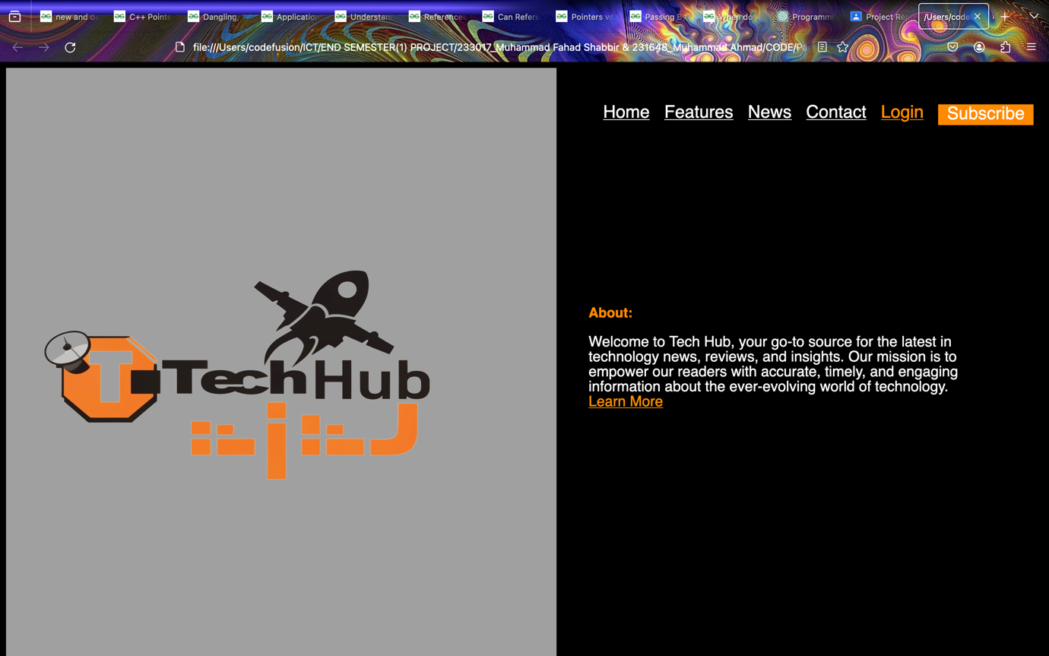

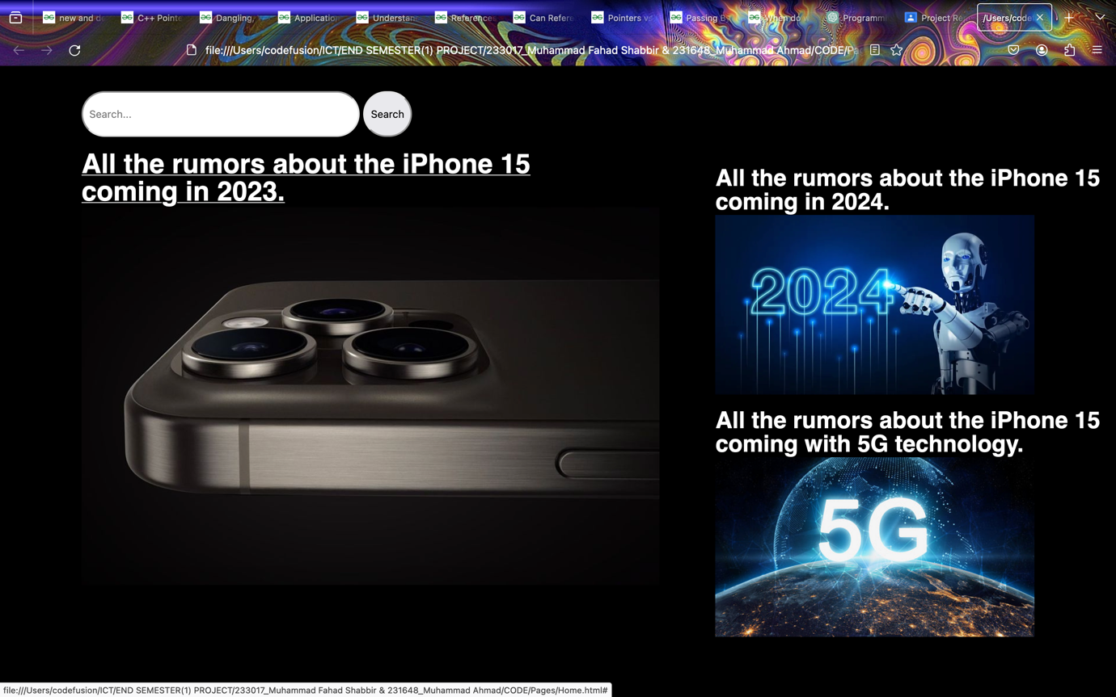

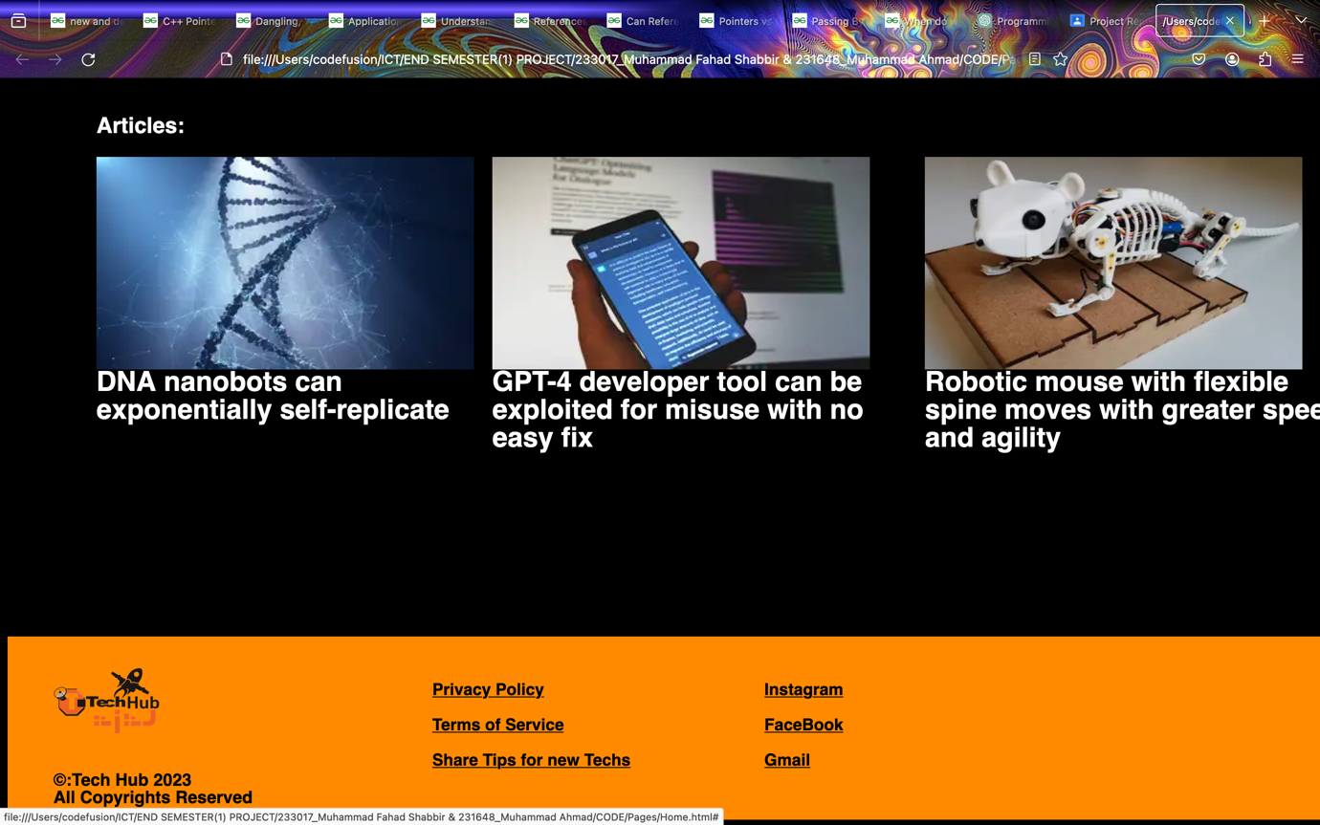

~**Implementation of navigation**~

Proper navigation bar is implemented which will have links to other pages such as Features, News, Contact, Login and Subscribe Button.

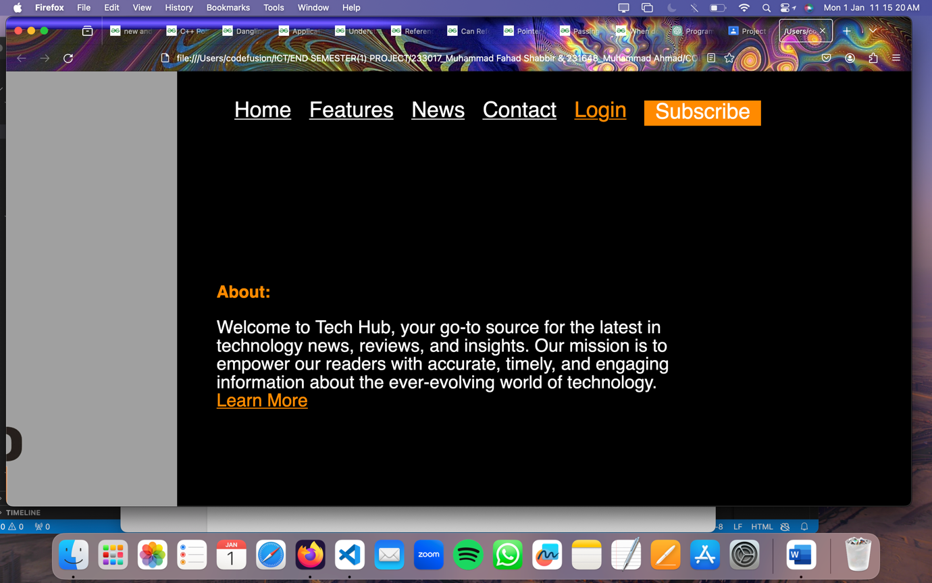

~**Design and Populate Sections**~

We have designed proper sections and linked pages in our website with videos and pictures wherever required and have used JavaScript to put condition to check for the email entered by the user on the subscribe page, whether it’s correct or not?

About Us Page

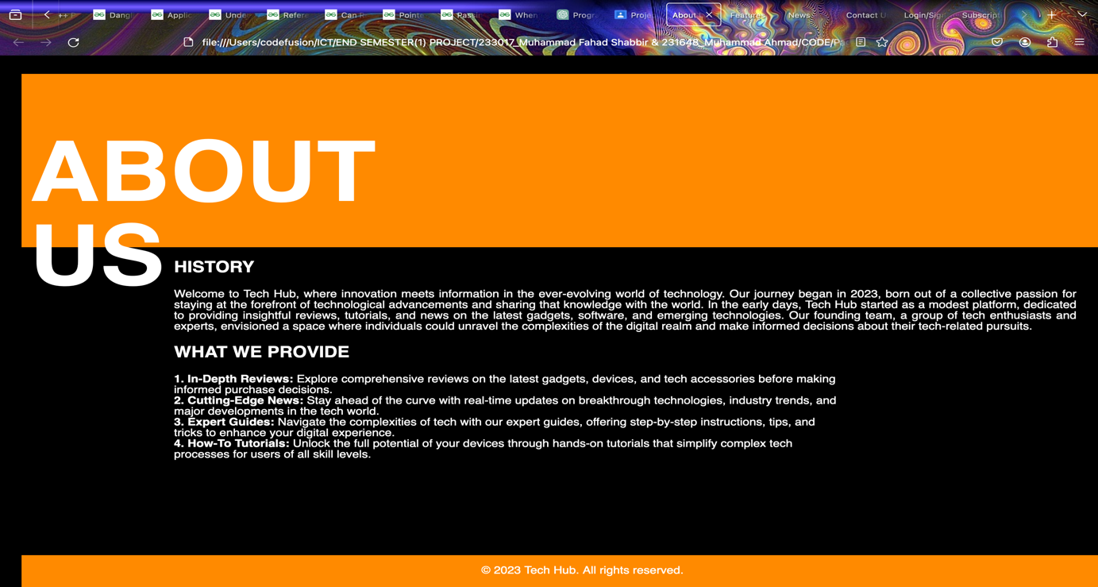

Features Page

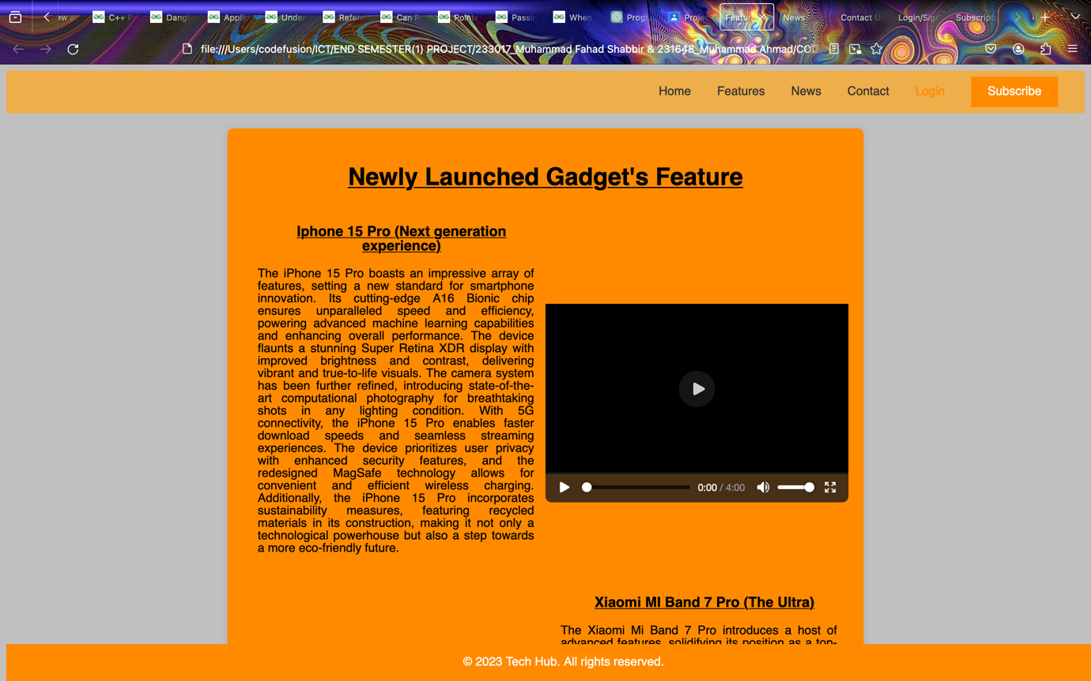

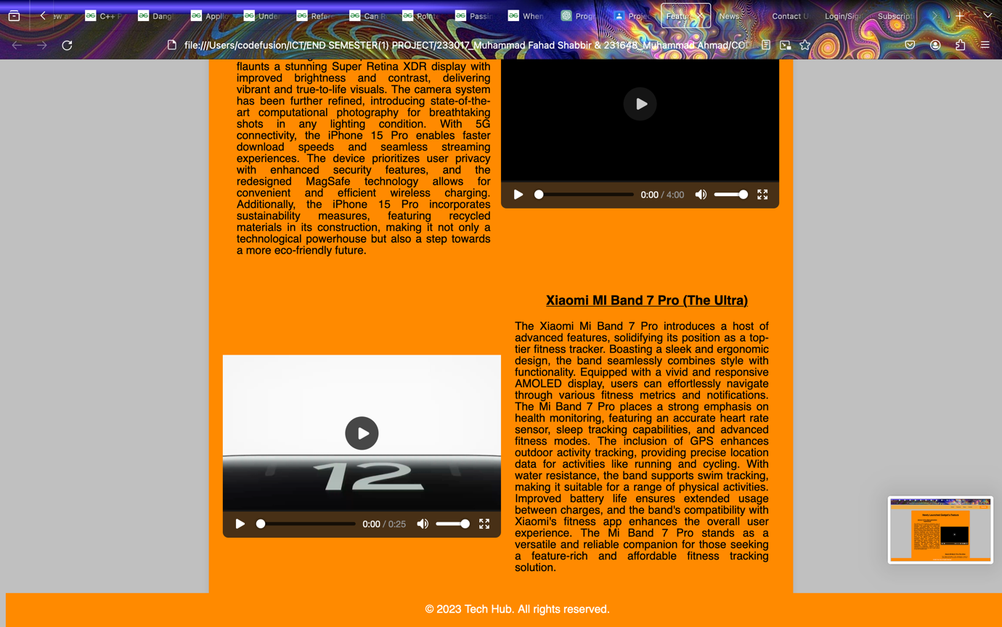

News Page

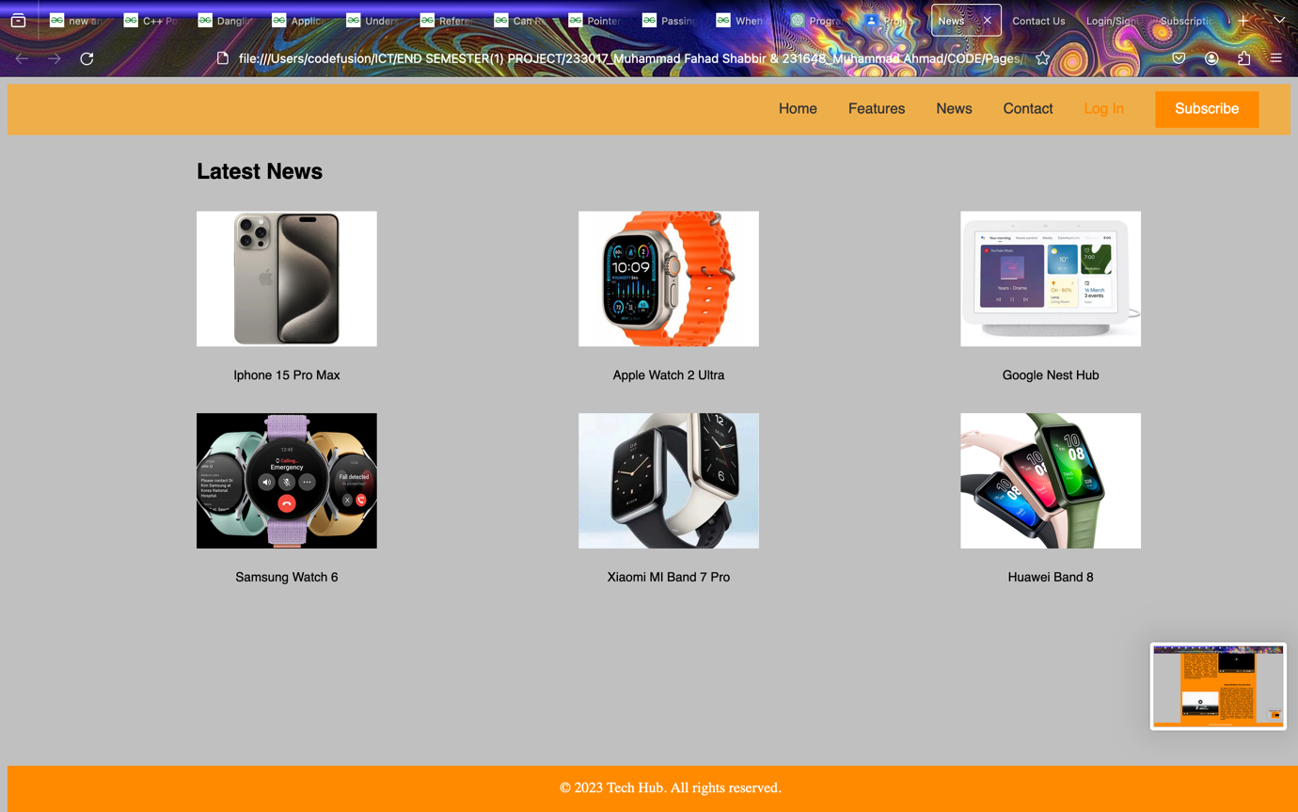

Login Page

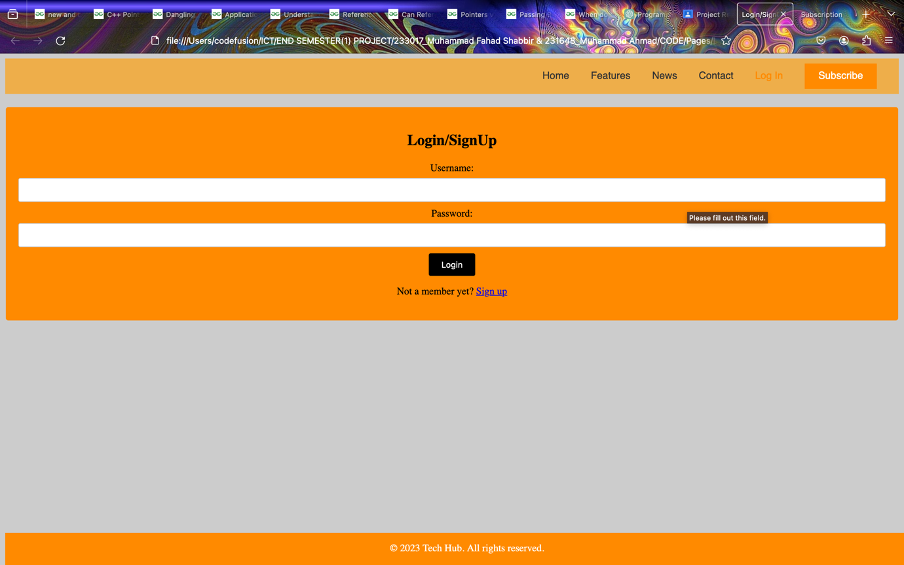

Subscribe Page



Contact Page

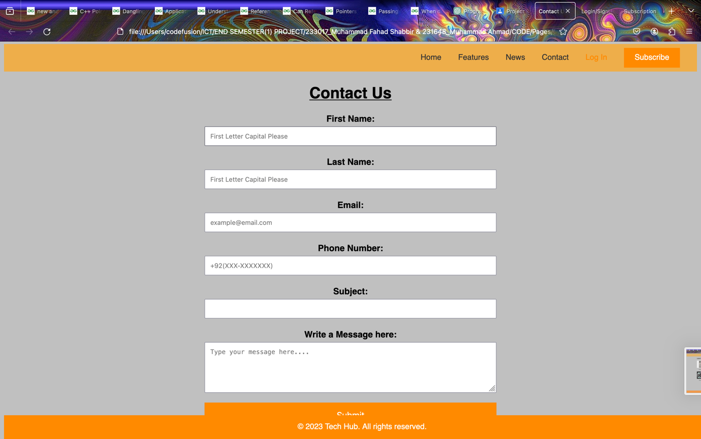

~**Responsive Design**~

Although our website is working on the MacBook Pro 14’’ as it was designed with similar frame in figma, and we applied same frame while coding in CSS for styling the height and width of the website. We haven’t used any queries for adaptive design as we have tried using the website on a normal mobile phone and the image is a bit zoomed out but appears fine. Can’t figure a way to put queries and how to manage it.

~**Git Repo Links and Profile Link**~